Arduino based on SMART HOME

By

M.ROOPANJALI

RA1611008010126

AIM:-To control home appliances with arduino by sending messege through WIFI module.

INTRODUCTION :-

The project aims at designing an advanced home automation system using NodeMCU ESP8266 module. The devices can be switched ON/OFF and read using mobile through Wi-Fi.

Wi-Fi:-is wireless technology that uses radio frequency to transmit data through the air. Wi-Fi transmit data in the frequency

Band of 2.4 GHz. The range of Wi-Fi technology is 40-300 feet.

Controlling devices for the automation of the project is NodeMCU. The data sent from mobile over Wi-Fi will receive by Wi-Fi module connected to NodeMCU. NodeMCU reads the data and decides the switching action of electrical devices connected to it through Relays.

* This project presents a design and prototype implementation of new smart home system.

* This uses WIFI technology as a network infrastructure connecting its parts.

* The main components of the system are WIFI Based Arduino, Relays.

* Arduino is a open source electronic platform based on easy to use hardware and software.

* Arduino boards are able to read inputs and convert it as an output.

* User can control electrical appliances with mobile phone using message and call.

*Relay which is acts a switch.

*A relay is an [electrically](https://en.wikipedia.org/wiki/Electric) operated [switch](https://en.wikipedia.org/wiki/Switch). Many relays use an [electromagnet](https://en.wikipedia.org/wiki/Electromagnet) to mechanically operate a switch, but other operating principles are also used, such as [solid-state relays](https://en.wikipedia.org/wiki/Solid-state_relay).

*By using moblies apps (blink,IOTapp,etc) operations are done.

**Requirement Analysis**:

SOFTWARE:

* Arduino IDE :- Makes it easy to write code & upload it to the board.

* DATABASE :- It will give connection to the Arduino to mobile operation.

HARDWARE:

* Relays :- it is an electrically operated switch.

* Jumpers :- that are electrical contact points.

* Arduino :- Arduino boards are able to read inputs and convert it as an output.

*.

* **B**read board :-A white board with holes that allow circults to be interconnect without soldering.

*12v Adaptors :-To supply power.

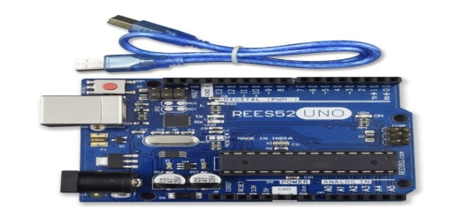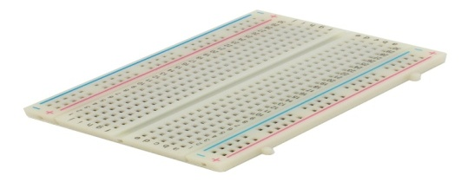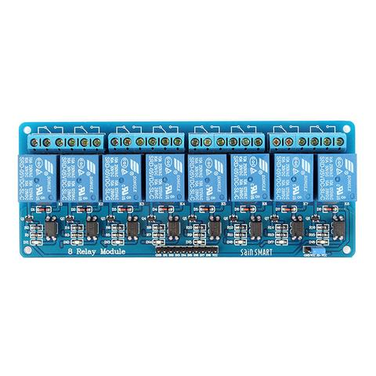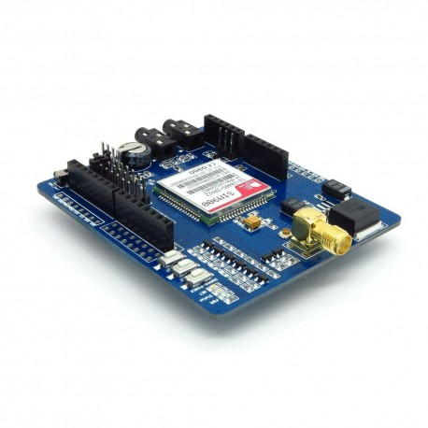

### 

### Circuit Diagram

### First we can connect ESP8266 with the Arduino Uno. The ESP8266 runs on 3.3V, it may damage if you connect it directly to 5V from Arduino. The pin out of the ESP-01 ESP8266 module is shown below.

### https://electrosome.com/wp-content/uploads/2016/12/Home-Automation-System-using-Arduino-and-ESP8266-Circuit-Diagram.jpg

### Connect the VCC and CH_PD of the ESP8266 to the 3.3V output pin of Arduino. CH_PD is Chip Power Down pin, which is active low. So we will give 3.3V to it, which will enable the chip. Then connect the TXD pin of the ESP8266 with the digital pin 2 of the Arduino. Then make a voltage divider to make 3.3V for the RXD of the ESP8266 which is connected to the pin 3 of Arduino. Here we are using software UART through digital pins 2 & 3 of Arduino. Lastly, connect the ground of the ESP8266 with the ground of the Arduino.

CODE:-

In programming part of this project, first of all in programming we includes library for smart home appliances.

#include <ESP8266WiFi.h>

#include "Adafruit_MQTT.h"

#include "Adafruit_MQTT_Client.h"

#define light D0

#define fan D1

#define WLAN_SSID "roopa"

#define WLAN_PASS "anjali24"

#define AIO_SERVER "io.adafruit.com"

#define AIO_SERVERPORT 1883

#define AIO_USERNAME "roopareddy"

#define AIO_KEY "42d5918d7cf34e9ca153d9bc7ecdef37"

WiFiClient client;

Adafruit_MQTT_Client mqtt(&client, AIO_SERVER, AIO_SERVERPORT, AIO_USERNAME, AIO_KEY);

Adafruit_MQTT_Subscribe onoffbutton1 = Adafruit_MQTT_Subscribe(&mqtt, AIO_USERNAME "/feeds/light");

Adafruit_MQTT_Subscribe onoffbutton2 = Adafruit_MQTT_Subscribe(&mqtt, AIO_USERNAME "/feeds/fan");

void MQTT_connect();

void setup() {

Serial.begin(115200);

delay(10);

pinMode(light,OUTPUT);

digitalWrite(light,LOW);

pinMode(fan,OUTPUT);

digitalWrite(fan,LOW);

Serial.println(F("IOT Based smart light"));

Serial.println();

Serial.println();

Serial.print("Connecting to ");

Serial.println(WLAN_SSID);

WiFi.begin(WLAN_SSID, WLAN_PASS);

while (WiFi.status() != WL_CONNECTED) {

delay(500);

Serial.print(".");

}

Serial.println();

Serial.println("WiFi connected");

Serial.println("IP address: ");

Serial.println(WiFi.localIP());

mqtt.subscribe(&onoffbutton1);

mqtt.subscribe(&onoffbutton2);

}

uint32_t x=0;

void loop() {

MQTT_connect();

Adafruit_MQTT_Subscribe *subscription;

while ((subscription = mqtt.readSubscription(5000))) {

if (subscription == &onoffbutton1)

{

Serial.println((char *)onoffbutton1.lastread);

uint16_t state1=atoi((char*)onoffbutton1.lastread);

digitalWrite(light,state1);

}

if (subscription == &onoffbutton2)

{

Serial.println((char *)onoffbutton2.lastread);

uint16_t state2=atoi((char*)onoffbutton2.lastread);

digitalWrite(fan,state2);

}

}

}

void MQTT_connect() {

int8_t ret;

// Stop if already connected.

if (mqtt.connected()) {

return;

}

Serial.print("Connecting to MQTT... ");

uint8_t retries = 3;

while ((ret = mqtt.connect()) != 0) { // connect will return 0 for connected

Serial.println(mqtt.connectErrorString(ret));

Serial.println("Retrying MQTT connection in 5seconds...");

mqtt.disconnect();

delay(5000); // wait 5 seconds

retries--;

if (retries == 0) {

// basically die and wait for WDT to reset me

while (1);

}

}

Serial.println("MQTT Connected!");}

}**CONCLUSIONS**

A Smart Home system integrates electrical devices in a house with each other. The techniques which are going to use in the home is the control of domestic activities, such as TV, fan, electric tubes, refrigerator and washing machine. After studying and understanding literature survey and other existing works. In this paper, we are planning to eliminate most of the human interaction by providing the intelligent system. Development of such Smart Home achieves by using the Internet of Things technologies. By using this system we can actually manage to make low cost, flexible smart homes to adjust its environmental conditions and resolve its errors with energy saving